Darius Quick
7/24/25
Module Four Assignment 2
Screenshot of the Get Method Execution Page
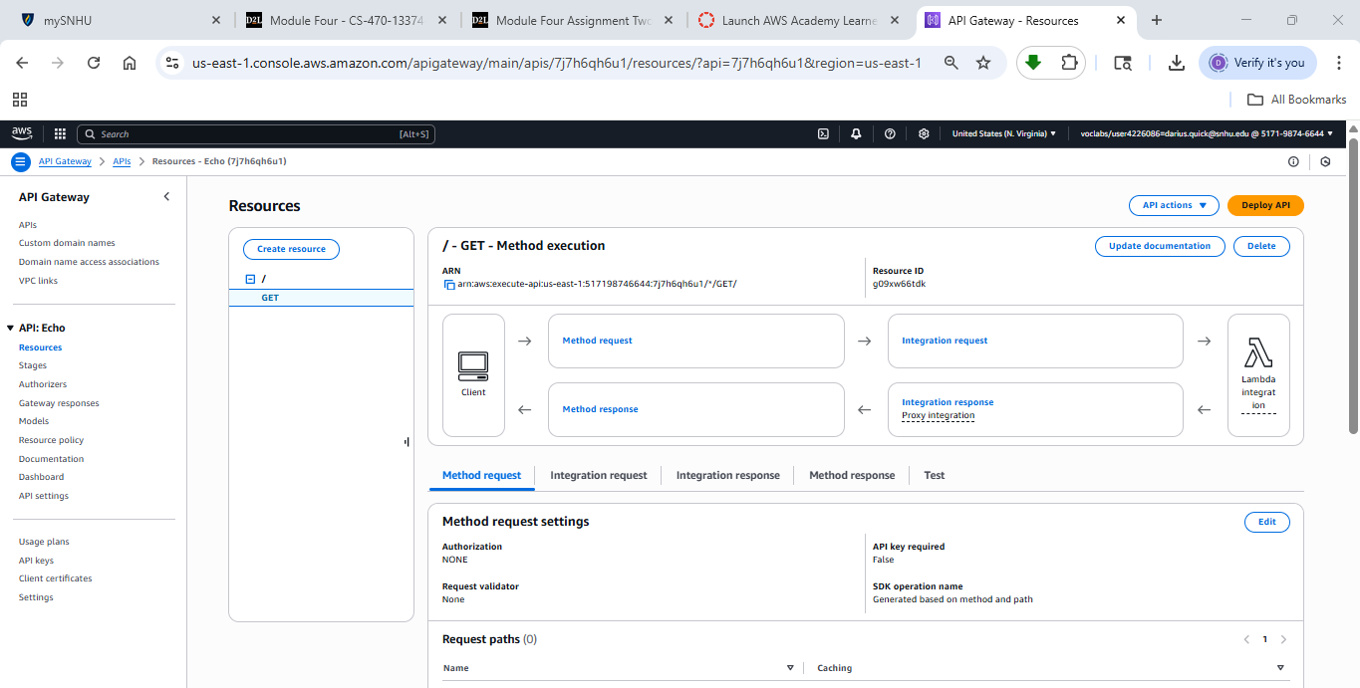
Screenshot of the Get Test Page 1
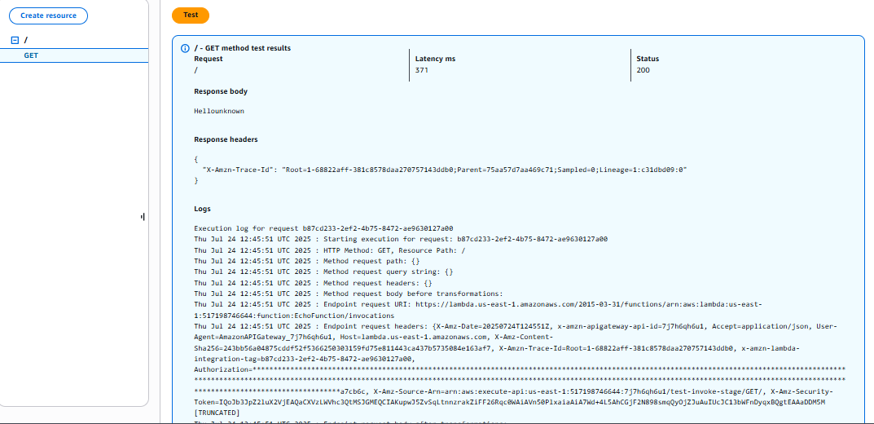
Screenshot of the Get Test Page 2
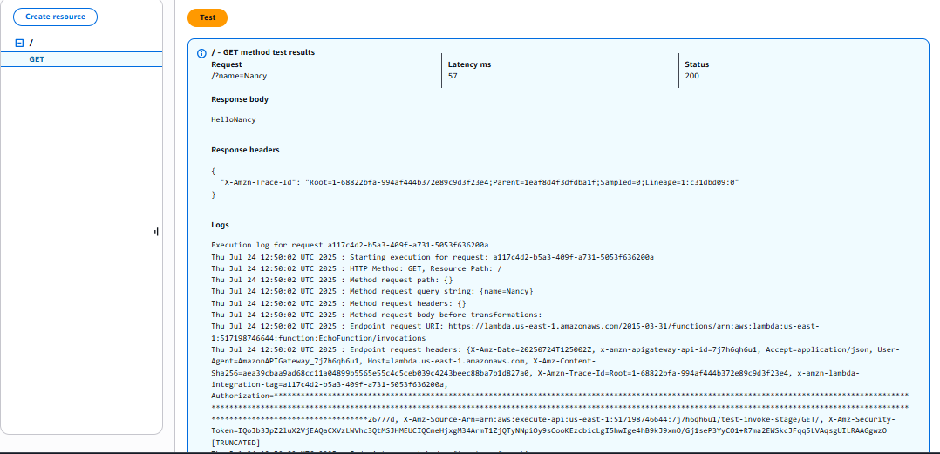
Screenshot of the Browser Running the URL
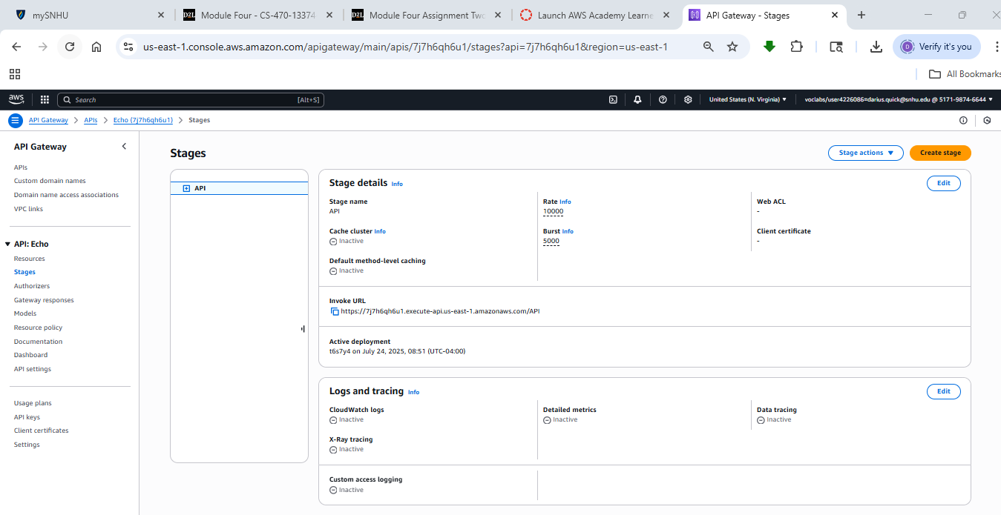
Screenshot of Invoking the URL From your Deployment
